**Consider the following table STUDENT.**

**Students**

|  |  |  |
| --- | --- | --- |
| **REGD.NO** | **NAME** | **BRANCH** |
| **0001** | **Ram** | **CSE** |
| **0002** | **Hari** | **MECH** |
| **0003** | **Pradeep** | **EEE** |
| **0004** | **Deepak** | **ETC** |

**1. Write down the SQL command which will show the Regd. No of Pradeep.**

**2. Write down the SQL command which will show the Name and Branch column.**

**3. Write a SQL command which will count the number of rows existing in STUDENT table.**

**4. I want to add another column in the STUDENT table as ”address”. How can I do that?**

**Consider the following table:**

**Employee**

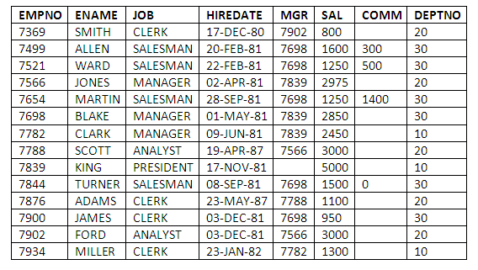

1. Create the above table.

2. Select the employees in department 30.  
3. List the names, numbers and departments of all clerks.  
4. Find the department numbers and names of employees of all departments with deptno greater than 20.  
5. Find employees whose commission is greater than their salaries.  
6. Find employees whose commission is greater than 60 % of their salaries.  
7. List name, job and salary of all employees in department 20 who earn more than 2000/-.  
8. Find all salesmen in department 30 whose salary is greater than 1500/-.  
9. Find all employees whose designation is either manager or president.  
10. Find all managers who are not in department 30.  
11. Find all the details of managers and clerks in dept 10.  
12. Find the details of all the managers (in any dept) and clerks in dept 20.  
13. Find the details of all the managers in dept. 10 and all clerks in dept 20 and all employees who are neither managers nor clerks but whose salary is more than or equal to 2000/-.  
14. Find the names of anyone in dept. 20 who is neither manager nor clerk.  
15. Find the names of employees who earn between 1200/- and 1400/-.  
16. Find the employees who are clerks, analysts or salesmen.  
17. Find the employees who are not clerks, analysts or salesmen.  
18. Find the employees who do not receive commission.  
19. Find the different jobs of employees receiving commission.  
20. Find the employees who do not receive commission or whose commission is less than 100/-.  
21. If all the employees not receiving commission is entitles to a bonus of Rs. 250/- show the net earnings of all the employees.  
22. Find all the employees whose total earning is greater than 2000/- .  
23. Find all the employees whose name begins or ends with ‘M’  
24. Find all the employees whose names contain the letter ‘M’ in any case.  
25. Find all the employees whose names are upto 15 character long and have letter ‘R’ as 3rd character of their names.  
26. Find all the employees who were hired in the month of February (of any year).  
27. Find all the employees who were hired on last day of the month.  
28. Find all the employees who were hired more than 2 years ago.  
29. Find the managers hired in the year 2003.  
30. Display the names and jobs of all the employees separated by a space.  
31. Display the names of all the employees right aligning them to 15 characters.  
32. Display the names of all the employees padding them to the right up to 15 characters with ‘*’.  
33. Display the names of all the employees without any leading ‘A’.  
34. Display the names of all the employees without any trailing ‘R’.  
35. Show the first 3 and last 3 characters of the names of all the employees.  
36. Display the names of all the employees replacing ‘A’ with ‘a’.  
37. Display the names of all the employees and position where the string ‘AR’ occurs in the name.  
38. Show the salary of all the employees , rounding it to the nearest Rs. 1000/-.  
39. Show the salary of all the employees , ignoring the fraction less than Rs. 1000/-.  
40. Show the names of all the employees and date on which they completed 3 years of service.  
41. For each employee, display the no. of days passed since the employee joined the company.  
42. For each employee, display the no. of months passed since the employee joined the company.  
43. Display the details of all the employees sorted on the names.  
44. Display the names of the employees, based on the tenure with the oldest employee coming first.  
45. Display the names, jobs and salaries of employees, sorting on job and salary.  
46. Display the names, jobs and salaries of employees, sorting on descending order of job and within job sorted on salary.  
47. List the employee names, department names and salary for those employees who have completed 1 year of service.  
48. List the employee names, department names and salary for those employees who are earning 0 commission or commission is null. Sort your output in the order of department name.  
49. List the employee names, department names and hiredate for those employees who have joined in 2003 . Sort your output in the order of joining date.